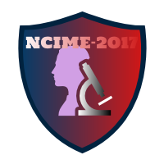

**Convener**

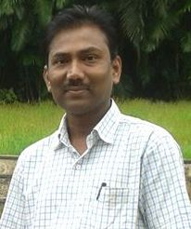

**Prof. A. G. Kamble**

**(Associate Professor, Mechanical Engineering)**

*The “5th National Conference on Innovations in Mechanical Engineering (NCIME- 2017)” is scheduled to be held during 17-18th March 2017 organized by Department of Mechanical Engineering at Sinhgad Institute of Technology, Lonavala. The conference focuses on fundamental research related to design and advances in Mechanical Engineering. The delegates will benefit from exchange of ideas which is the basic agenda of this conference. There has been a good response to the call for papers. Number of research papers has been received from the researchers and academicians of the leading institutes and organizations all over the India. These technical papers give a true account of current research and development trends in the field of Mechanical Engineering.*

*We are extremely grateful to the authors of the papers, reviewers, national advisory committee members, faculty and non teaching staff members of the department of Mechanical Engineering and students for their cooperation and sincerity. We are deeply indebted to Dr. M. S. Gaikwad, Principal of our Institute for their constant support and encouragement in making this national conference a success.*